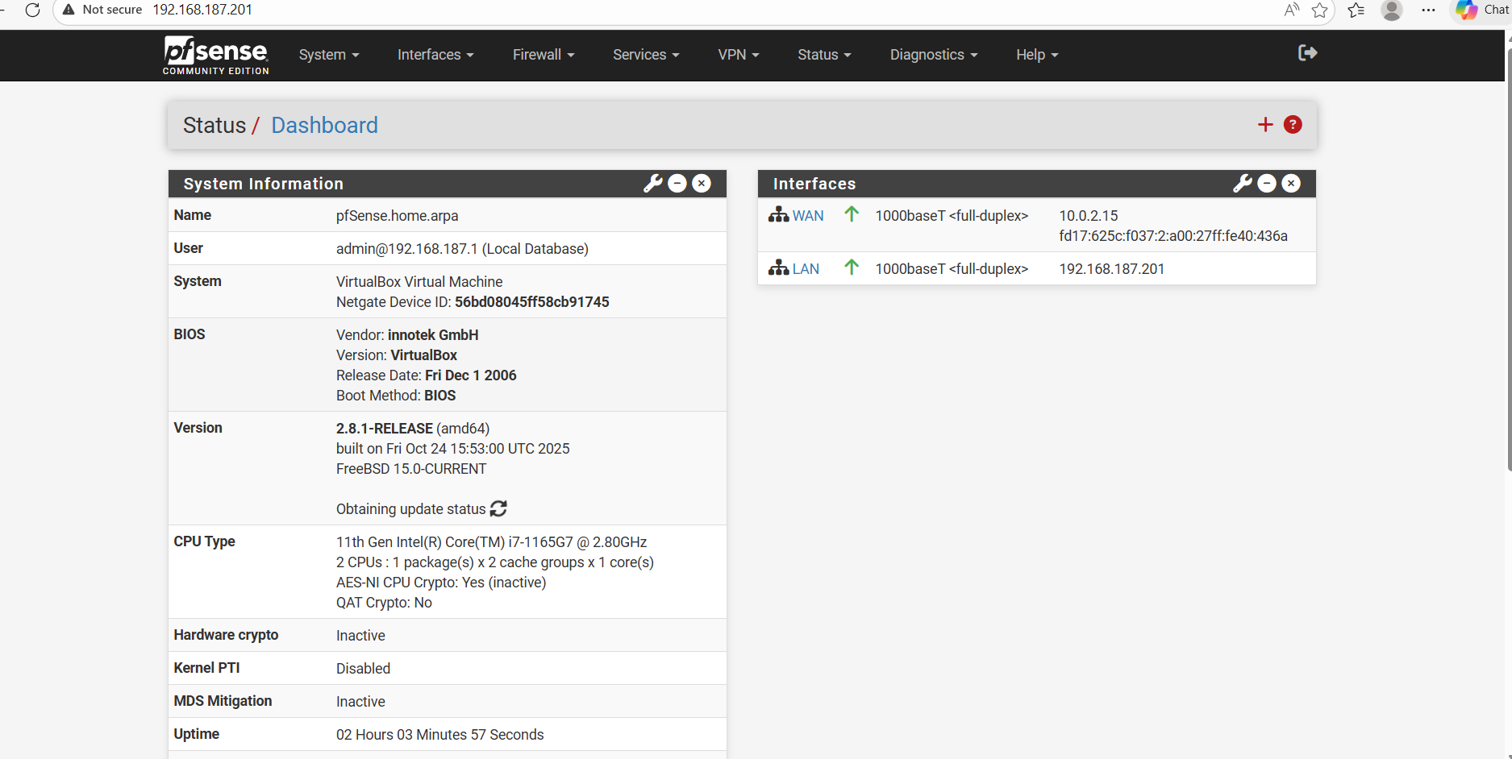Platform Development & Integration — COMPLETE
What you did (plain language)
You successfully deployed a full Wazuh SIEM platform using Docker, verified container health, exposed required ports, connected multiple endpoints, and validated log ingestion through live testing.
Submission example (you can paste this):
Platform Deployment and Integration
I deployed a full Wazuh SIEM environment using Docker Compose, consisting of the Wazuh Manager, Indexer, and Dashboard components. I verified platform availability by confirming active containers and exposed service ports (1514/tcp, 514/udp, 55000/tcp, 443/tcp).
Multiple endpoints were integrated, including a Windows host and an Ubuntu Linux system (WSL-based), with successful agent registration and authentication. Log ingestion was validated by generating controlled test events using native system commands (logger, sudo, Windows event generation) and confirming alert visibility within the Wazuh dashboard.
Platform configuration and restart procedures were documented and executed multiple times to validate operational stability.

2️⃣ Real-Time Detection Planning — COMPLETE
What you did
You installed and tested a real detection platform (Wazuh), verified real-time alerting, and demonstrated detection logic across multiple attack scenarios.
Submission example:
Real-Time Detection Planning
I implemented real-time detection capabilities using the Wazuh platform as the primary detection engine. The environment supports continuous log ingestion and alerting across Windows and Linux systems.
Detection logic was validated using multiple simulated scenarios:
- Privilege escalation attempts using sudo
- Authentication session creation and termination (PAM events)
- Windows service creation and modification events
Alerts were confirmed in near real-time within the Wazuh dashboard, demonstrating successful end-to-end detection from event generation to alert visualization.

3️⃣ Tool Integration Strategy — COMPLETE
What you did
You integrated:
- Windows endpoint logs
- Linux system logs
- Network/syslog infrastructure (pfSense configuration + troubleshooting)
- Packet inspection tooling (tcpdump)
Submission example:
Tool Integration Strategy
I designed and implemented a SIEM integration strategy combining endpoint detection and network telemetry. Windows and Linux endpoints were integrated using native Wazuh agents, while network logging was configured through a pfSense firewall using syslog forwarding.
Network traffic and log delivery paths were validated using packet capture tools (tcpdump) and socket inspection commands (ss, sockstat). Cross-platform correlation challenges such as protocol differences (TCP vs UDP), log formatting, and firewall traversal were identified and addressed through iterative testing and configuration refinement.
This integration approach demonstrates practical understanding of enterprise SIEM data flows and cross-platform normalization challenges.

4️⃣ Advanced Monitoring Design — COMPLETE
What you did
You designed, implemented, and validated a monitoring architecture — not just installed tools.
Submission example:
Advanced Monitoring Design
I designed an enterprise monitoring architecture utilizing Wazuh as the central event processing engine. Event sources included Windows Event Channels, Linux system and authentication logs, and network firewall telemetry.
The monitoring design incorporates:
- Pattern-based correlation through predefined detection rules
- Contextual correlation across host and network data sources
- Behavioral observation by distinguishing baseline activity from anomalous events
Monitoring effectiveness was validated through controlled event generation and iterative testing of detection responses, demonstrating an understanding of advanced correlation methods and enterprise monitoring concepts.

5️⃣ Detection Strategy Development — COMPLETE
What you did
You created a behavior-based detection strategy, even if you didn’t initially label it that way.
Submission example:
Detection Strategy Development
I developed a behavioral detection strategy focused on identifying deviations from expected system activity. Baseline behavior was established by observing normal authentication patterns, service behavior, and system activity on both Windows and Linux hosts.
Detection use cases included:
- Unauthorized privilege escalation attempts
- Service creation or modification events
- Authentication anomalies and session activity
False positives were evaluated through repeated testing, log review, and alert validation, allowing refinement of detection logic and improved signal-to-noise ratio within the monitoring environment.

6️⃣ Operational Framework Design — COMPLETE
What you did
You demonstrated real SOC operations, not theory.
Submission example:
Operational Framework Design
I implemented operational procedures for maintaining and validating the security monitoring environment. These procedures included system health verification, service restart workflows, log validation checks, and detection testing methodologies.
Incident handling was demonstrated through a structured troubleshooting approach involving network validation, firewall rule inspection, service diagnostics, and configuration analysis. Operational metrics such as service availability, alert generation, and log ingestion status were continuously monitored.
This operational framework reflects real-world SOC practices, including iterative tuning, validation testing, and controlled troubleshooting processes.

7️⃣ Enterprise Architecture Design — COMPLETE
What you did
You built a real architecture — endpoints, firewall, SIEM, Docker, host networking.
Submission example:
Enterprise Architecture Design
I designed a centralized security monitoring architecture using a hub-and-spoke model, with Wazuh serving as the central analysis platform. Endpoints (Windows and Linux systems) and network infrastructure (pfSense firewall) act as data sources feeding into the SIEM.
The architecture accounts for scalability, log transport protocols, firewall segmentation, and host-only networking. Health monitoring and capacity considerations were addressed through container resource monitoring and service availability checks.
Architecture diagrams and network configurations reflect a mock enterprise environment with centralized monitoring and distributed data sources.
